Project Approval

•Project Name And Version

AndroidTalk Version 0.1

•Project Introduction And Objective

It’s a project as practice of android speech to text and speech recognition .

We’ll make version 0.1 in the first part time . Make a tts and ts application with service . we can use speech to control dialing , go to web , google search , start app, operations in android.This version only supports English language ..

•Planing and Requirement

See the detailed documents in attechments .

## •Team

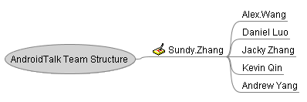

•Peroid

November 1. 2010 – November 21 2010

PM Sign _____Sundy.Zhang_____ Date stamp_ Nov.1 2010_______

Customer Sign ______________________ Date stamp_________________